**Haunted Library**

Friday, October 21st

& Saturday, October 22nd

5:00pm-9:00pm

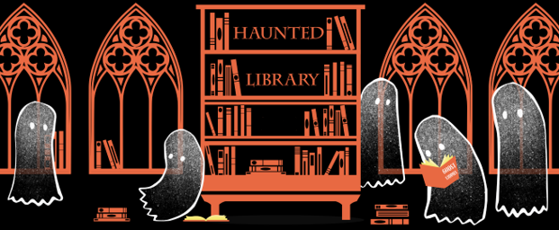Join us for fun, games, and spooky frights throughout the night!

Open to kids of all ages.